MODULE 1 — AI Tool Comparison Report
Cursor IDE · ChatGPT · GitHub Copilot

1. Introduction
This report compares three leading AI coding tools — ChatGPT, GitHub Copilot, and Cursor IDE — across a range of practical development tasks. The goal is to understand each tool's strengths, weaknesses, and best use cases through hands-on testing.

- Understand AI tool categories and core capabilities
- Evaluate feature sets across common development workflows
- Identify strengths, weaknesses, and privacy implications
- Provide actionable recommendations for tool selection

2. Test Project
A simple Express.js CRUD application was built and used as the base for all tests. Each AI tool was evaluated on the following five tasks:

- Task 1: Code generation — Express app creation
- Task 2: Code explanation — Understanding existing code
- Task 3: Bug detection — Identifying errors in code
- Task 4: Refactoring — Improving code structure
- Task 5: Validation logic — Generating input validation

3. Test Screenshots

Test 1 — Express App Creation
Cursor IDE
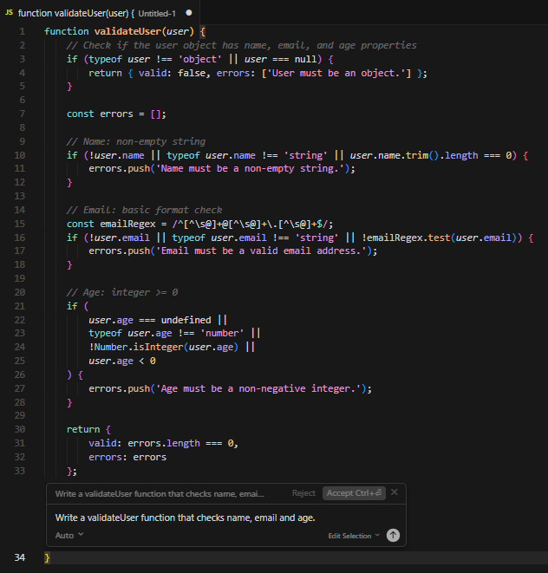
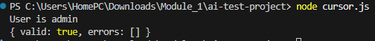

ChatGPT
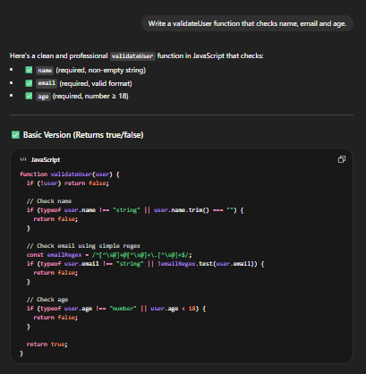
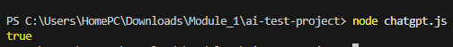
GitHub Copilot
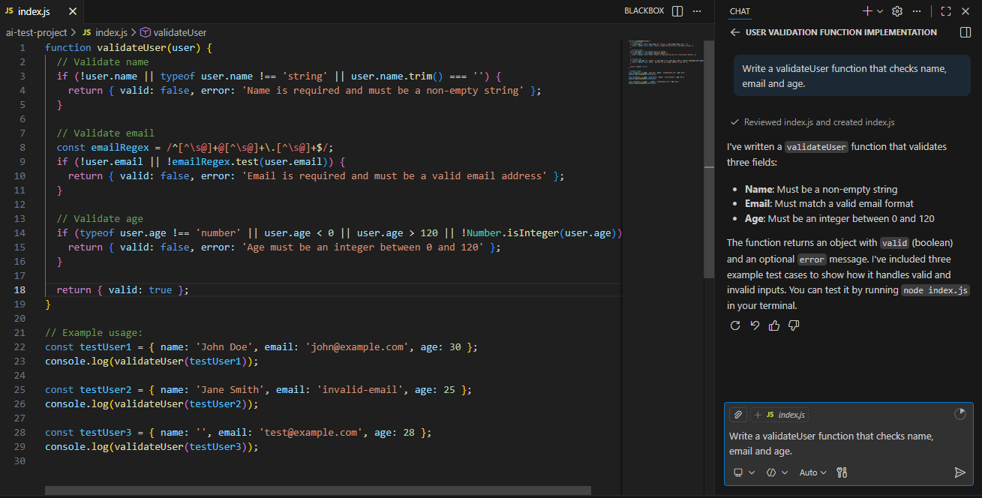
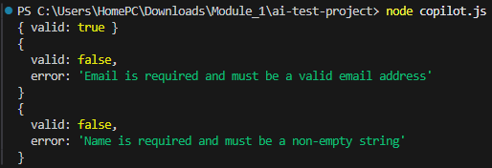

Test 2 — Code Explanation
Cursor IDE
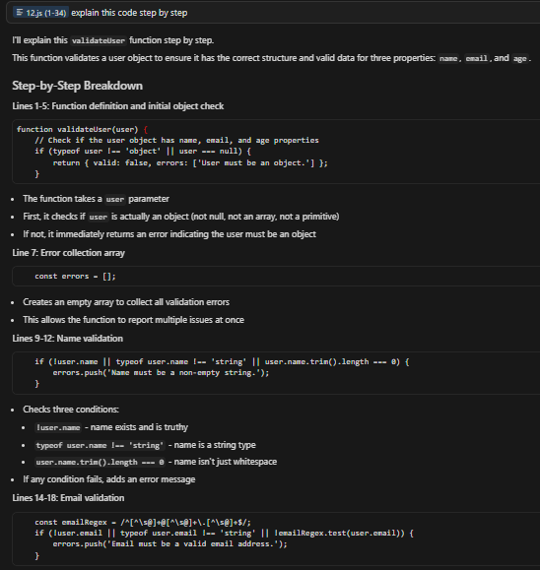
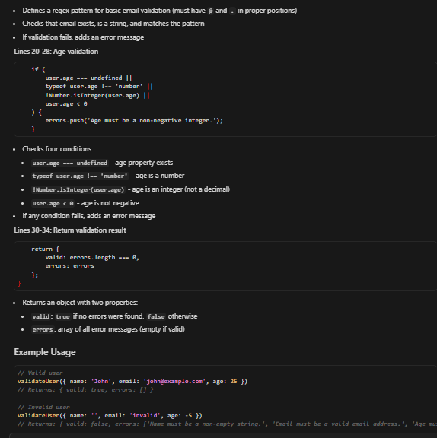
ChatGPT
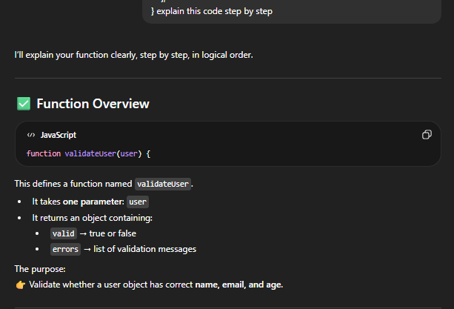
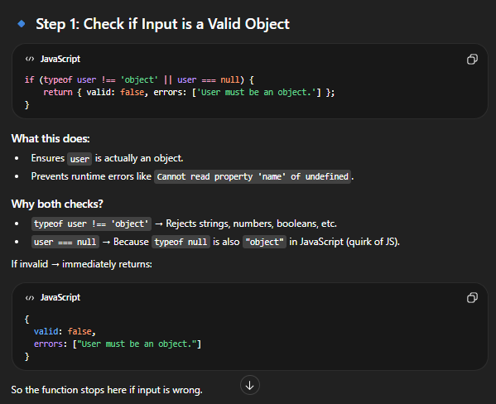
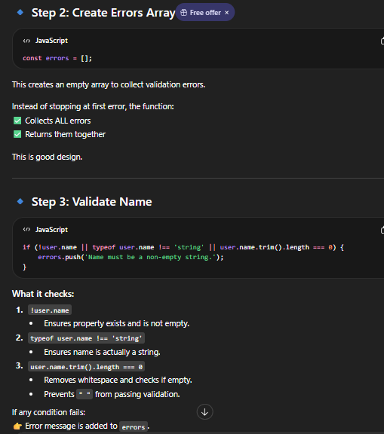
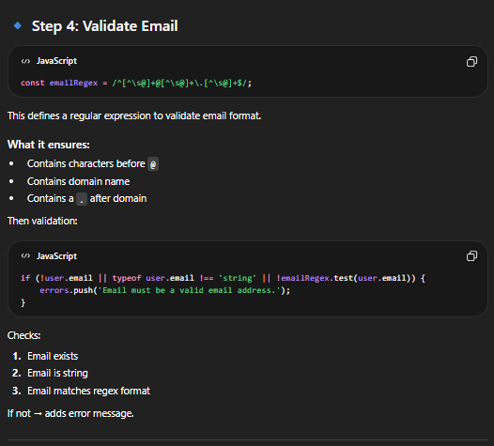
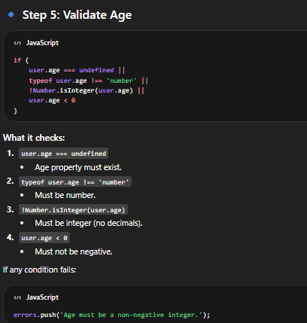
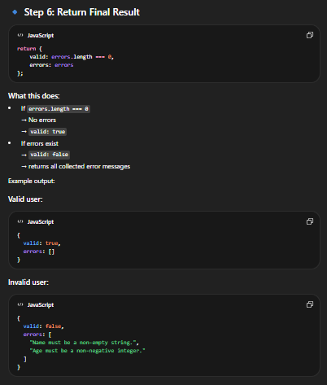
GitHub Copilot
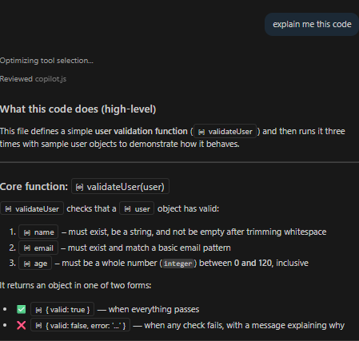

Test 3 — Bug Detection
GitHub Copilot
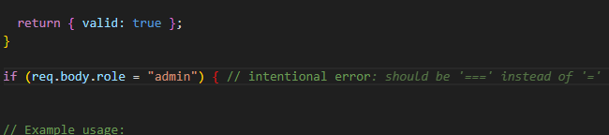
Cursor IDE
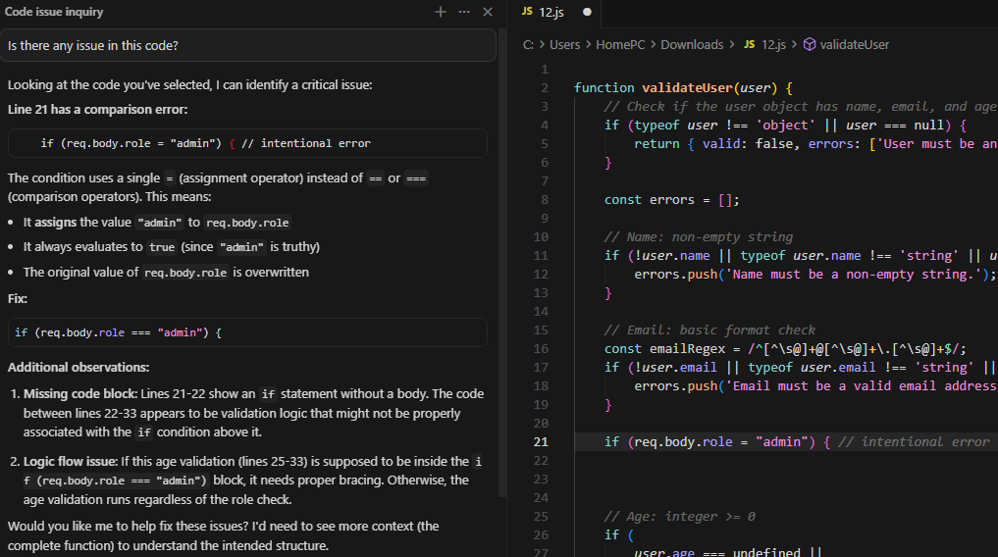

ChatGPT
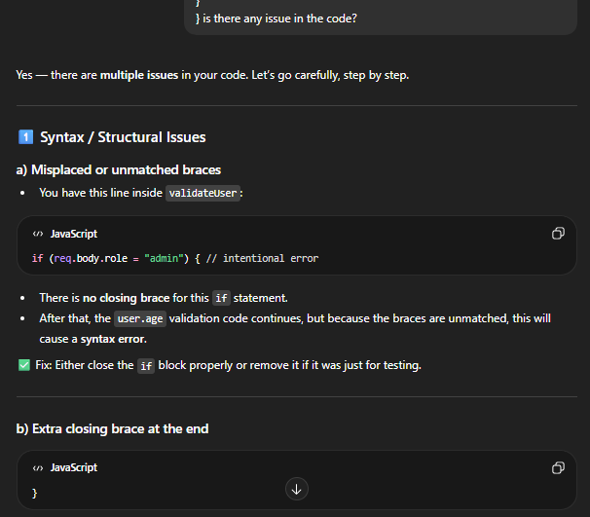
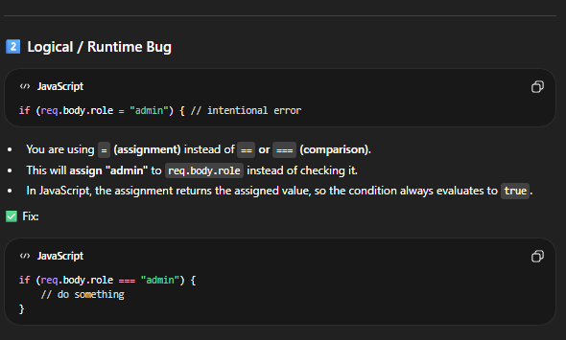

Test 4 — Refactoring
GitHub Copilot
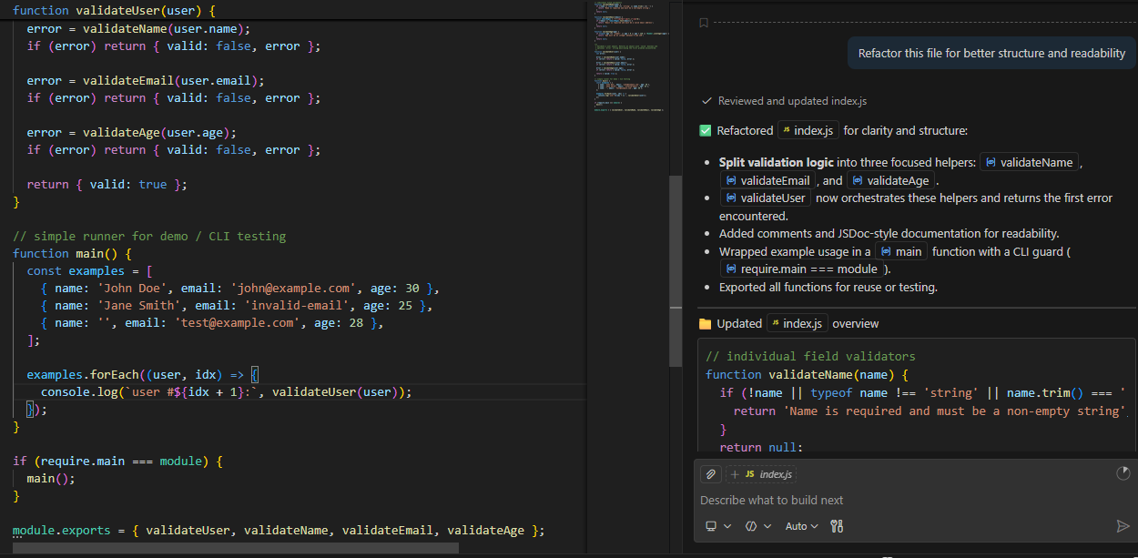
Cursor IDE
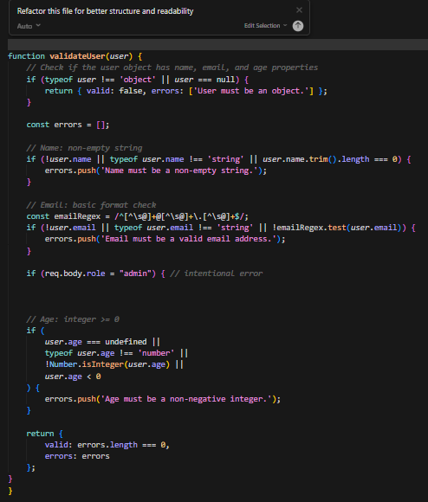

ChatGPT
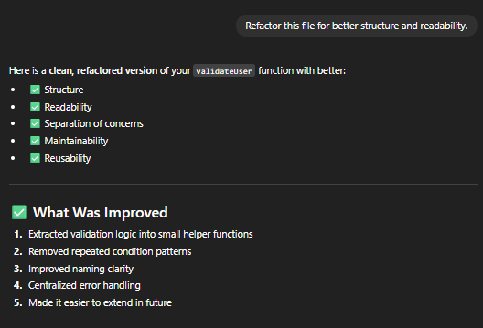
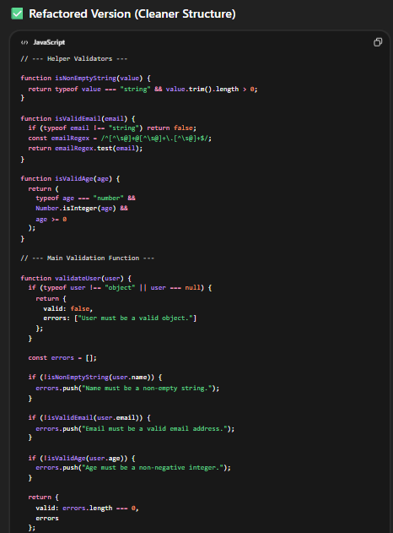

4. Feature Comparison

Feature | ChatGPT | GitHub Copilot | Cursor IDE
Autocomplete | Manual prompt | Fast | Context-aware
Project Context | Limited | File-level | Full project
Code Explanation | Strong | Moderate | Strong
Refactoring | Suggested | Limited | Advanced
Debugging | Reasoning | Quick fix | Contextual
Documentation | Detailed | Basic | Structured

5. Strengths & Weaknesses

ChatGPT
- ✅ Strengths: Strong reasoning engine, detailed and comprehensive code explanations, excellent for architecture discussions
- ⚠️ Weaknesses: No native IDE integration; requires manual copy-paste workflow

GitHub Copilot
- ✅ Strengths: Fast inline autocomplete, seamless IDE integration, low friction for repetitive code
- ⚠️ Weaknesses: Limited deep reasoning; less effective for complex logic or architectural decisions

Cursor IDE
- ✅ Strengths: Full project-level context awareness, advanced refactoring, structured documentation generation
- ⚠️ Weaknesses: Requires paid subscription; steeper learning curve for new users

6. Risks & Privacy
All three tools process code in the cloud. The following risks and mitigations apply:

- 🔒 Secret exposure: Never paste API keys, credentials, or sensitive configuration into any AI prompt.
- 🐛 Bug introduction: AI-generated code may contain subtle errors or insecure patterns — always review before committing.
- 🏢 Enterprise policy: Check your organization's data-sharing policies before using cloud-based AI tools with proprietary code.
- 🛡️ Mitigation: Use environment variables, enforce code review, and treat AI output as a first draft.

7. Responsible AI Usage
- Never share production secrets, passwords, or tokens in AI prompts
- Always review and test AI-generated code before committing
- Use AI as a productivity assistant, not a replacement for engineering judgment
- Document assumptions made by the AI and validate them independently

8. Conclusion
Each tool excels in a distinct area. The right choice depends on your workflow and use case:

🔍 Best for explanation & architecture | ChatGPT
⚡ Best for coding productivity | GitHub Copilot
🔧 Best for refactoring & project context | Cursor IDE

For most teams, using a combination of tools — Copilot for day-to-day coding and ChatGPT or Cursor for deeper analysis — will yield the best results.

